Underlying Technologies
You can think of OpenStack Compute as a toolkit for building a cloud computing environment by stitching(拼接) together existing Linux technologies.
The figures below shows two examples of how these underlying technologies can be assembled to construct an OpenStack Compute cloud. The circles are Linux services that are part of OpenStack Compute, and the rectangles are external (not maintained by the OpenStack project) components. Solid lines show interactions between OpenStack components and external components, and dashed lines show interactions between external components. All services that are part of OpenStack Compute interact with a queueing backend (e.g., RabbitMQ, Qpid) and a database backend (e.g., MySQL, PostgreSQL); these connections are not shown. Also not shown are services that do not explicitly rely on external technologies. For example, the nova-api service, the Identity service, and the Image service are not shown.
1.圈子的linux服务是openstack服务的一部分
2.矩形是外部组件
3.实线表示openstack组件和外部组件的交互
4.虚线表示外部组件的交互
5.openstack全部的服务通过后端队列和数据库后端交互。这些链接不被显示。也不明确的 显示对外部技术的依赖。

一. Underlying technologies (Scenario 1)
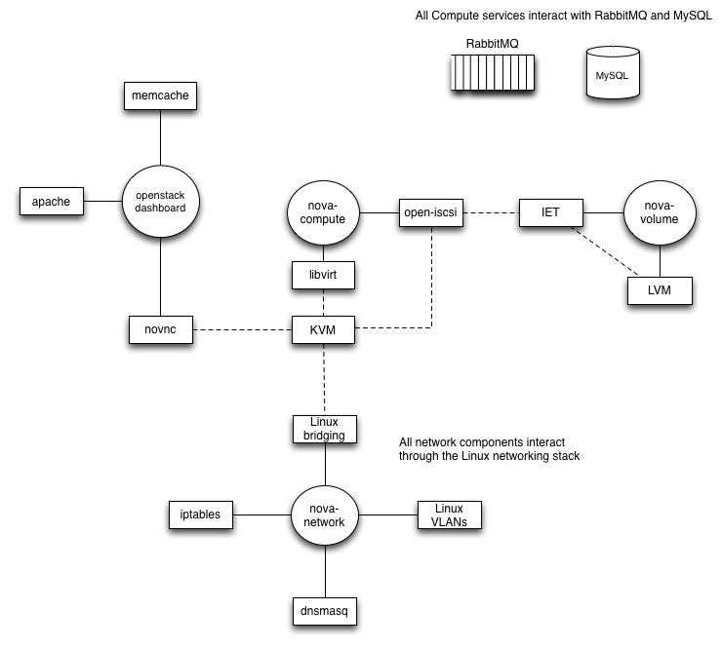

二.Underlying technologies (Scenario 2)
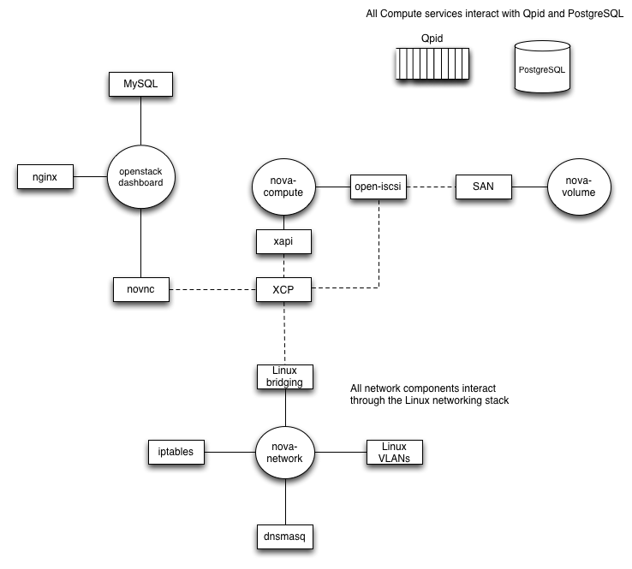
三.Many of the external technologies can be substituted with other components, as shown in the table below.
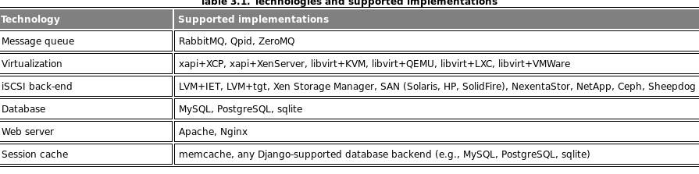

四.nova-compute
The nova-compute service depends on a virtualization driver to manage virtual machines. By default, this driver is libvirt, which is used to drive KVM. However, the libvirt driver can also drive other hypervisor technologies, and there is a separate Xen virtualization driver for driving Xen-based virtual machines if configured to use Xen Cloud Platform (XCP) or XenServer. Open-iscsi is used to mount remote block devices, also known as volumes. Open-iscsi exposes these remote devices as local device files which can be attached to instances.
nova-compute依赖虚拟化技术来管理虚拟机。默认通过 libvirt，由KVM驱动。

五.nova-network
The nova-network service depends on a number of Linux networking technologies. It uses Linux bridging to create network bridges to connect virtual machines to the physical networks. These bridges may be associated with VLANs using Linux networking VLAN support, if running in the VLAN networking mode. Iptables is used to implement security rules and implement NAT functionality, which is used for providing instances with access to the metadata service and for supporting floating IP addresses. Dnsmasq is used as a DHCP server to hand out IP addresses to virtual machine instances, as well as a DNS server.
In a future OpenStack release, functionality that is currently implemented by nova-network will be available through a separate OpenStack project, codenamed Quantum.
Nova-network 以来依赖多种linux网络技术。使用桥接创建桥接网络链接虚拟机到物理机。
在未来的技术中， Nova-network实施的功能将被分离出来，由名为 Quantumopenstack项目代替

六.nova-volume
By default, the nova-volume service uses LVM to create and manage local volumes, and exports them via iSCSI using IET or tgt. It can also be configured to use other iSCSI-based storage technologies.
In the Folsom OpenStack release, functionality available through nova-volume is also available through a separate OpenStack Volumes project, code-named Cinder.
Nova-volume 使用LVM创建本地 volumes和输出他们的 via iSCSI using IET or tgt。在将来的发行版本中使用 Cinder代替

七.openstack-dashboard
The openstack-dashboard is a Django-based application that runs behind an Apache web server by default. It uses memcache for the session cache by default. A web-based VNC client called novnc is used to provide access to the VNC consoles associated with the running KVM instances.
openstack-dashboard基于 Django-based的应用，默认使用apache web服务器。使用 memcache会话缓存。使用基于叫做novnc web的VNC客户端提供访问到VNC控制台。

